News letter March 01 2015 No. 1
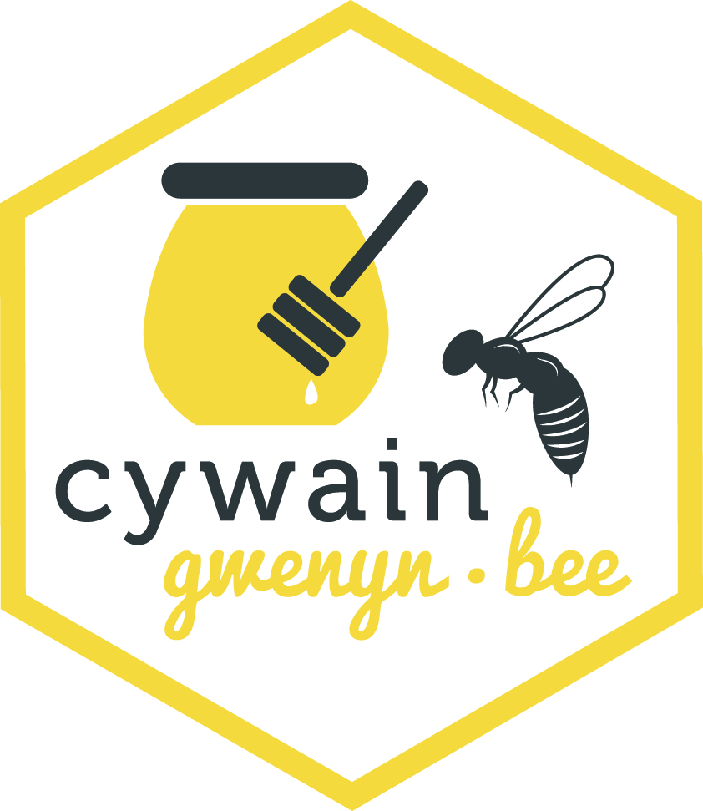
Year colour is-----BLUE
The busy bee has no time for sorrow--- WILLIAM BLAKE
Some dates for your diary
March o2 2015—“Beekeeping and the law” at Association meeting
March 07 2015—AGM of WBKA
March 28 2015—WBKA Convention Builth Wells
April 21 for six weeks CBKA Beginners Course at the Association Apiary

Hello to all our readers
The first one for 2015 carries belated season greetings
During the quiet time we have been maintaining stored kit, consulting Bee suppliers’ catalogues and again referring to those reference books in the hope someone has already experienced the problems you have had in the past season.
Your new committee held its inaugural meeting in late January and welcomed the outgoing committee’s input and on behalf of the association thanked them for their efforts .
Welsh Beekeepers’ AGM will take place and the years program will be broadcast and hope THE ASSEMBLY and indeed Central Government (National Pollinator Strategy launched by Environmental Secretary in November 2014) are still championing the need to increase the honey crop and providing the environment we need to promote the welfare of the pollinating insects. My “Queen Bee” informs me that the W.I. have contributed to the campaign to
“SAVE THE HONEYBEE”. Thank you ladies for your support and congratulations for winning “The Third Sector “awards for your part in the campaign. So if the statistics are right that means at least half the population support it.
A reported better last season for the honey crops---do not forget the bees must take precedence when gathering your rewards.
With much already happening in the Apiary and surroundings. Easter is not far away and SHE will be still in a laying in earnest The hedgerows may in your locale be offering up pollen and nectar. The snowdrops, crocus have long since
bloomed and with the “pussy willow” provided pollen supply for the new seasons colonies. To feed or not to feed, that is the question.?
NB If you want to move or plant snowdrops (Galanthus} do so while still in the green.
What colour is the pollen of the crocus?
Refer to –Pollen Loads of the Honeybee by Dorothy Hodges

Beware the possible early tell tale of swarm preparation
Seed catalogues have been out since November and has given the gardener time to decide what to grow or plant this year-------------anything that provides sustenance for our ladies especially installing a wide range of fruit trees and plants. The bees eagerly await the first flowers of the plum family.
All the shows again this year require stewards, free entry -----tea and cakes----- access to friends old and new---and doing what we enjoy spreading the word about the Bee and her contribution.
We have secured some funding from CYWAIN. This will allow Colin as Apiary manager and our education co-ordinator, along with his able assistant to organise this year's programme of training for those who require it at very nominal sum. —ADVERTISE THIS FUNCTION AT ALL AND EVERY OPPORTUNITY-in the paper shop, the pub, village hall notice boards, supermarket free notice boards, anywhere people congregate (beware planning restrictions of bill posting). The funding will allow us to advertise in local press.
Access to the young is restricted these days by necessary protective arrangements but we should still where possible nurture any interest.
Books for your “Apiacta” shelf I cannot assume the handle of Grumpy old Beekeeper as a much wiser person than I has the mantle---but nevertheless I will “voice an opinion from time to time”---leave out the Queen excluder!!!!!. This season I am trying it with one colony and will let you know how it goes, after all a wild bee colony has no resemblance of queen exclusion and relies does it not on the fact that the queen will not “cross the honey” I must admit I have been influenced by “The Rose Method” by Tim Rowe published by GREEN HAT BOOKS (ISBN NO 9780956702616)
Ensure we read the Welsh Beekeeper –continuing the spectre of
Asian Hornet in Wales and the Small Hive Beetle presence in Europe (only a short distance to us!!!
Our friend Wally Shaw has been busy again with his recent booklet—AN APIARY GUIDETO SWARM CONTROL
Become a Citizen Scientist—Ref. IBRA CSI Pollen Project with Norman Carreck ND
-------And from Brian
With the weeks passing quickly don't forget to check that your colonies have enough stores. For emergency feeding a bag of sugar dampened and cut then placed as near as possible to the cluster should be fine. If you can feed Fondant, Candy or a propriety bee feed all the better. Don't feed syrup till later in the spring when it gets a lot warmer
------And from Colin in the Apiary
Thank you to Tim Rand for his expert help in erecting the new Apiary shed and thanks to B&Q for their consideration in supplying it to us.
Attached earlybird application form for tickets this year's convention March 28
Items for inclusion in the June issue to j_p14w4@talktalk.combyMay 18 2015
Do you want a swarm if available this year, contactour swarm co-ordinator
See you again in June
jp

