News letter June 2015 No. 2 Year colour is BLUE
HELLO TO OUR READERS
…………..so work the honey bees,
Creatures that by a rule in nature teach
The act of order to a peopled kingdom WILLIAM SHAKESPEARE – Henry V
SOME DATES FOR YOUR DIARY
- June 27 2015 Comb Identification Workshop at Newchurch Communal Hall. Reminder and directions to follow - a truly worthwhile visit
- August 01 2015 Garden Party/field day by kind invitation of Henry and Shirley Masters. Details to follow.
- Apiary meetings every Sunday afternoon in June, July & August
- We are planning a “Wax” workshop prior to the honey show so we can all compete with confidence in that class It’s never too early to start preparing for the honey show.

The value of the swarm you missed!!!!
A swarm in June is worth a silver spoon;
A swarm in July is not worth a butterfly Traditional Ireland
-------------------------------------
The association library has a wealth of information and recent additions complimenting the collection. Make good use of this free source.
Contact Sarah Marchant or Ann Brown for access to the Library.
-----------------------------
Recommended for your own bookshelf-----
The Healing Power of Pollen and other products from the beehive
By Maurice Hanssen—published by Thornsons ISBN 0 7225 0526 4

Don’t forget to read the Welsh Beekeeper to read informative articles such as “To Clip or Not to Clip That Is the Question” by Wally Shaw and Frank Gellatly

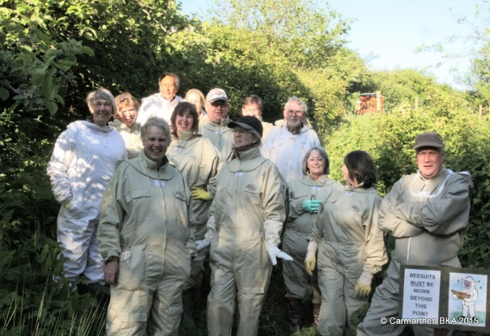
REPORT ON BEGINNER’S COURSE 2015

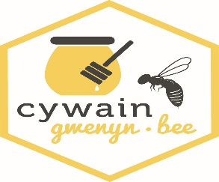
Our Apiary manager / Education officer Colin masterminded and managed the Beginners Course over 6 weeks for eight candidates and after a few additions finished with eleven. We now have at least another eleven members with a basic understanding of the craft and willing to practice what they have been taught, initially by attending the summer Sunday meetings and then eventually with their own colonies.
We would also like to thank Cywain Bee who provided funding for the course, which enabled us to hire equipment for each trainee such as protective clothing and numerous training aids.

FROM COLIN – IN THE APIARY
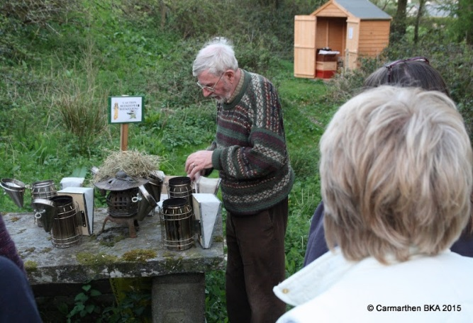
The course started on April 21 with eight people present. Topics covered, protective clothing, gloves, hive tools and smokers.
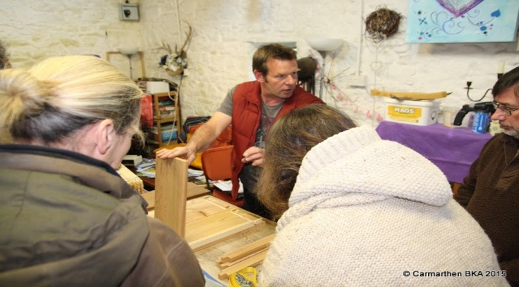
Week Two we covered different types of bee’s origins etc understanding the difference between the queen, workers and drones annual life cycle.
Week Three we looked at all the parts of the bee hive and Tim Rand gave a very good demo on how to put a hive together.
Week Four we covered record keeping. Vetinary medicines, law insurance and how to set up your apiary.
Then the students had their first meeting with the bees, we divided the students into two groups Margaret took one and I took the other. We went into the apiary and opened up some of the hives and the students were shown procedures involved in handling the bees.
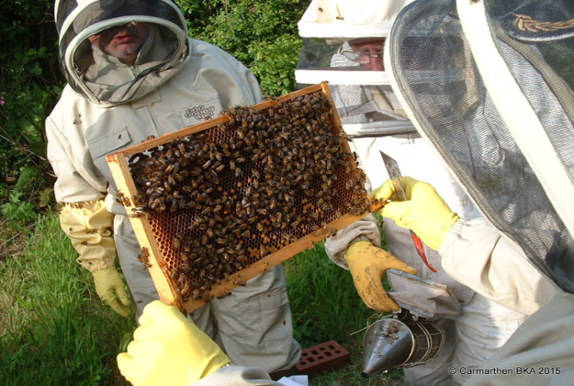
Weeks Five and Six. Again the students were divided into two groups again Margaret had one group and I had the other and the students had “hands on” experience in handling the bees.
They had to identify the different casts of bees, check for eggs larvae, brood and whether it was sealed or not. They also had to identify stores and pollen.
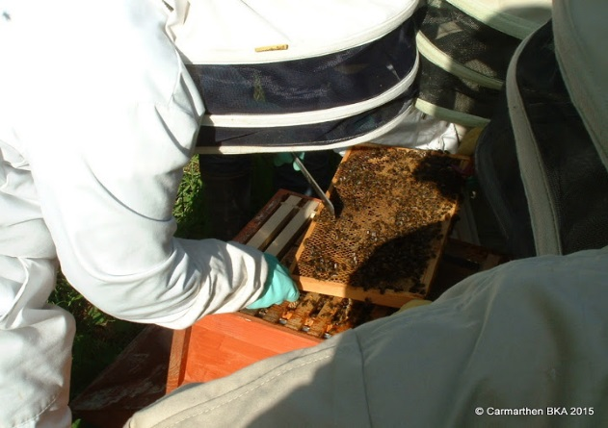
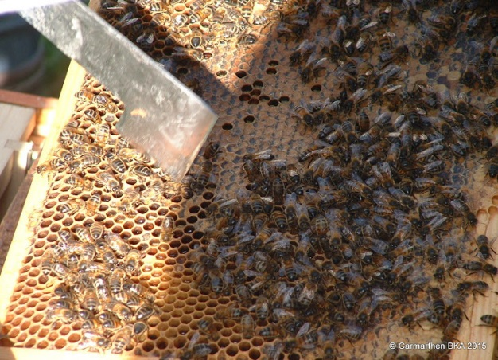
The students were shown how to artificially swarm a hive of bees.

I would like to thank Margaret for all her help and also our resident photographer Steve.
Finally a big THANK YOU to the tea ladies who provided our much needed “cuppa” and all their delicious homemade cakes.

Pollen Survey at the National Botanic Garden

Following the arrival of the bees into the Bee Garden, the science students are starting a project seeking to shed light on the foraging habits of honeybees. Throughout the summer the science department will be sampling pollen collected by the bees and honey from the hives. Using DNA barcoding it will be possible to identify the plants that the pollen came from and therefore can conclude which plants the bees have been visiting. Part of the survey will be looking at plants which are in flower in the Gardens every month. This will provide an idea of what plants are available to the bees.
Using this information, the science team will be able to answer questions like...
Do honeybees favour native plants over non-native plants?
Between individual hives, is there variation in the plants that honeybees visit?
Do the bees favour specific areas of the Garden and does this vary between the hives and throughout the season?
The surveying task is too large for the science students to complete on their own and the volunteer conservation group have kindly volunteered to assist them. However, the more people involved in the survey, the easier the task of surveying will be! Exceptional botanical knowledge of plants is not required, as the majority of plants in the garden are labelled. Survey sheets will be provided to complete for certain areas, for example the Slate Beds.
Surveys will be carried out on the last Tuesday of every month as follows:
30th June, 28th July, 25th August, 29th September and 27th October.
Although Jake, Tegan and Abi will not be at the Garden after the end of June, they will still be involved with the project to a certain extent, and will be in communication with the volunteer conservation team.
So if you would like to help, please let me know, meeting in reception in the stable block at 10am, 30/06/2015.

Thanks, Jane. jane.down@gardenofwales.org.uk Tel: 01558 667118
And you may like to know that it hardly ever rains on a Tuesday morning, in the last 2 years I understand that the conservation volunteers have had less than 5 damp days! Tuesday mornings are the driest at the Garden, though of course this could be famous last words!!!

Useful tips to ease your beekeeping from Brian Jones

HIVE STAND LEGS
Plastic squares cut from scrap window sills and screwed onto the base of Hive Stands will stop the water from seeping up and rotting the woodwork. This is also useful for the floors on Double Walled hives.

SMOKER AFTER USE
Extinguish your smoker after use to save burning down the bee shed or setting the field alight. A small wooden plug or cork attached to the smoker by a chain is useful for this. Or the whole smoker can be put in a lidded metal box.

Anyone else have any good tips or tricks to pass on? Please let the editors know so they can be included in future editions.

The editor has learnt a new word NADIRING as applied to beekeeping.
Putting another box underneath. An archaic term used by Warre hive users
Dictionary definition = lowest point. As opposed to ZENITH = Highest point.
-----------------------------------------
Your editors previously advertised intention to “try” the Rose Method did not get off the ground as the colony chosen to experiment with “disappeared” over winter
Another attempt will be made if a new swarm is forthcoming.
----------------------------------------------------
New American research now points to Nosema Ceranae as being the possible cause of colony collapse disorder, rather than the Varroa mite.
NB: Nosema Ceranae has also been found in Bumble bees.
Colin
For all you internet users out there a website called “Plos One” has loads of articles on the subject. Just search for the word ‘Nosema’
--------------------------------
NOTES FROM A NOVICE BEEKEEPER
We all start somewhere and this member did “from the beginning”…
In 2009 I decide to act on a long held notion that I would like to keep bees. After consulting with an old friend, an experienced beekeeper, I duly became a member of CBKA in January 2010.

Having left full time education longer ago than I would care to admit, the winter talks and films provided a valuable, if incomprehensible at times, insight into what I would be letting myself in for.

Come Spring the die was cast as flat packs of equipment were purchased, along with all the other necessary accoutrements for the apprentice be bee keeper; bee suit, smoker, hive tool etc. Just in case!

Having dusted off my carpentry skills, learnt as a child from my father, I set to work in the kitchen preparing brood boxes, supers and frames. Many hours, bent nails, sore hands and unspeakable language later, I had assembled the beginnings of my apiary. Dad would have been proud.

The winter talks gave way to spring and summer practical sessions at the Association apiary, where experienced beekeepers acted as mentors to the beginners who learnt how to assemble hives, frames, insert foundation etc. How I wish I’d waited.

As the weather grew warmer, thoughts turned to the bees and the daunting prospect of our first encounter with tens of thousands of stinging insects. Initial, tentative, ham fisted attempts to remove and examine frames, look for eggs, larvae and the ever elusive Queen, slowly developed into something resembling a confident approach to dealing with the hive, much to the relief, I’m sure, of the long suffering bees.

In July my friend, who decided that I’d spent long enough “thinking about keeping bees”, offered me a nuc. There was no going back.

Throughout the summer the nuc developed into a thriving colony of gentle, contented bees. At inspection times I was helped by another novice who had joined CBKA at the same time as me but who didn’t yet have bees. Together we pored over the frames experiencing all the fascinating details of the hive that our winter talks had prepared us for; eggs, larvae, sealed brood, drone brood, pollen and stores, not to mention the dreaded Varroa mite. We even saw the Queen.

Autumn, time to think about settling the bees down for the winter. The half brood seemed to be full of honey but gave a couple of feeds of syrup to be on the safe side. In view of large quantity of Varroa present I asked another member, who had developed a way of administering oxalic crystals at this time of year with no detriment to the bees, to come and treat my colony. This was done at the end of October with no apparent effect on the bees but a significant mite drop some days later. Put on mouse guard and crossed everything for the winter ahead.
Ann Brown
-------------------------------

The editor would like to thank all contributors for their articles and would like to encourage other members to do the same.

ITEMS FOR SEPTEMBER NEWSLETTER
Please send any articles or other items of interest to our new newsletter editor
Kim Relf at kim@mclweb.net

